23AI2003 –Artificial Intelligence for Web Development Lab
URK23CS5003

Ex. No: 08 | Node.js+MySQL Event Registration

Aim

To develop a web-based event registration system using Node.js, Express, and MySQL that allows users to register for events and enables administrators to search registration details.

Description
The application allows users to register for multiple events through an HTML form by entering their register number, name, and selecting events from given options. The form data is sent to a Node.js server built using Express, where validation is performed to ensure that no more than three events are selected and duplicate registrations are avoided. The validated data is then stored in a MySQL database. The system also provides an admin search feature where the administrator can retrieve registration details using a register number. If the entered register number exists, the corresponding details are displayed; otherwise, an appropriate message is shown. This experiment demonstrates full-stack integration involving frontend form handling, backend processing, database storage, validation, and data retrieval using Node.js and MySQL.

Code
index.html
<!DOCTYPE html>
<html>
<head>
<title>Event Registration</title>
</head>
<body>

<h2>Event Registration Form</h2>

<form action="/register" method="POST">
Register Number:
<input type="text" name="regno" required><br><br>

Name:
<input type="text" name="name" required><br><br>

Select Events (Max 3):<br>

<input type="checkbox" name="events" value="Coding Challenge"> Coding Challenge<br>
<input type="checkbox" name="events" value="Debugging Contest"> Debugging Contest<br>
<input type="checkbox" name="events" value="Web Design"> Web Design<br>
<input type="checkbox" name="events" value="Quiz Competition"> Quiz Competition<br>
<input type="checkbox" name="events" value="Paper Presentation"> Paper Presentation<br><br>

<button type="submit">Register</button>

</form>

</body>
</html>

Search.html

<!DOCTYPE html>
<html>
<head>
<title>Search Registration</title>
</head>
<body>

<h2>Search Registration</h2>

<form action="/search" method="POST">
Enter Register Number:
<input type="text" name="regno" required>
<button type="submit">Search</button>
</form>

</body>
</html>

Server.js

const express = require('express');
const bodyParser = require('body-parser');
const mysql = require('mysql2');
const path = require('path');

const app = express();
const port = 3000;

app.use(bodyParser.urlencoded({ extended: true }));

// MySQL connection
const db = mysql.createConnection({
host: 'localhost',
user: 'root',
password: 'aruna',
database: 'eventdb'
});

db.connect((err) => {
if (err) {
console.log("Error connecting to MySQL:", err);
} else {
console.log("Connected to MySQL");
}
});

// Home route
app.get('/', (req, res) => {
res.send("Server + MySQL Connected!");
});

app.get('/form', (req, res) => {
res.sendFile(__dirname + '/index.html');
});

app.post('/register', (req, res) => {
const { regno, name, events } = req.body;

if (!events) {
return res.send("Error: Please select at least one event");
}

let eventList = events;

if (!Array.isArray(eventList)) {
eventList = [eventList];
}

if (eventList.length > 3) {
return res.send("Error: Maximum 3 events allowed");
}

const eventString = eventList.join(", ");

const sql = "INSERT INTO registrations (regno, name, events) VALUES (?, ?, ?)";

db.query(sql, [regno, name, eventString], (err, result) => {
if (err) {
if (err.code === 'ER_DUP_ENTRY') {
return res.send("Error: Register number already exists");
}
return res.send("Database error");
}

res.send("Registration successful!");
});
});

app.get('/search', (req, res) => {
res.sendFile(__dirname + '/search.html');
});

app.post('/search', (req, res) => {
const regno = req.body.regno;

const sql = "SELECT * FROM registrations WHERE regno = ?";

db.query(sql, [regno], (err, results) => {
if (err) {
return res.send("Database error");
}

if (results.length === 0) {
return res.send("No record found");
}

const data = results[0];

res.send(`
<h2>Registration Details</h2>
Register Number: ${data.regno} <br>
Name: ${data.name} <br>
Events: ${data.events}
`);
});
});

// Start server
app.listen(port, () => {
console.log(`Server running at http://localhost:${port}`);
});

Input & Output
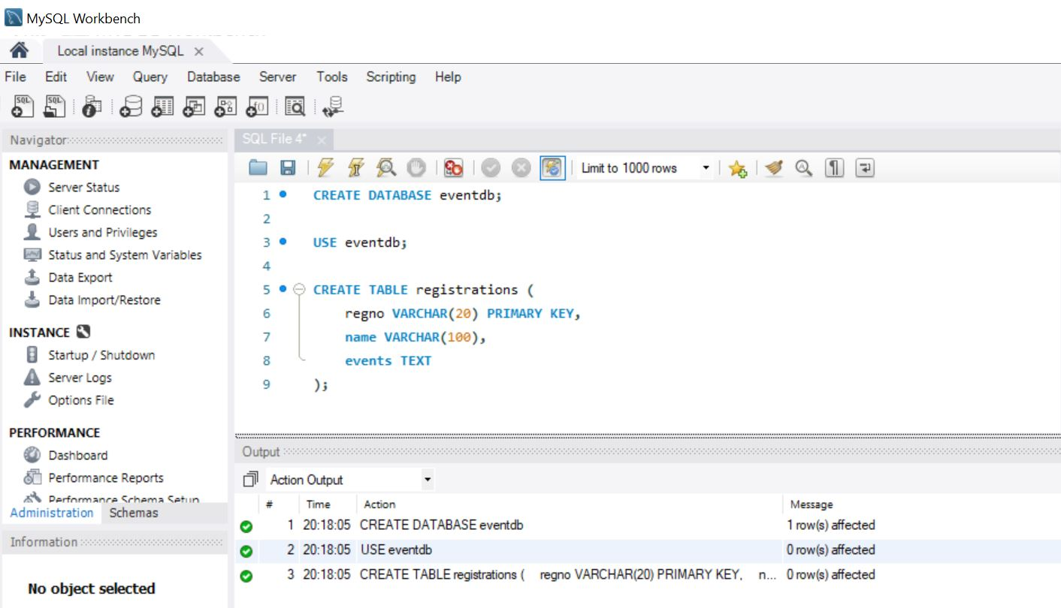

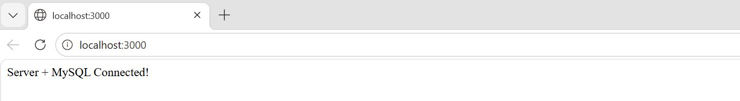

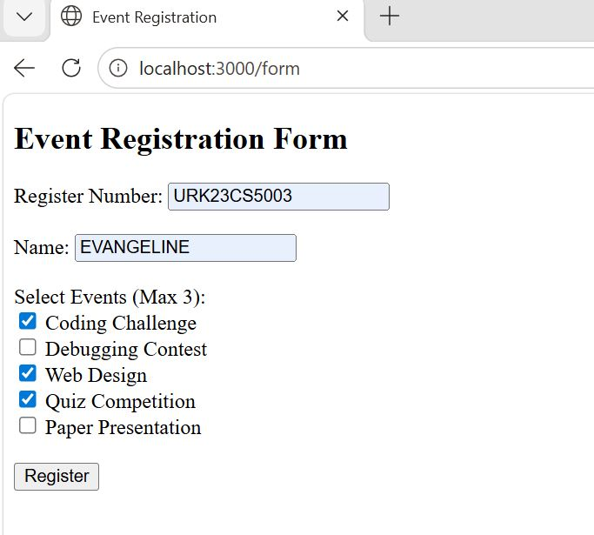

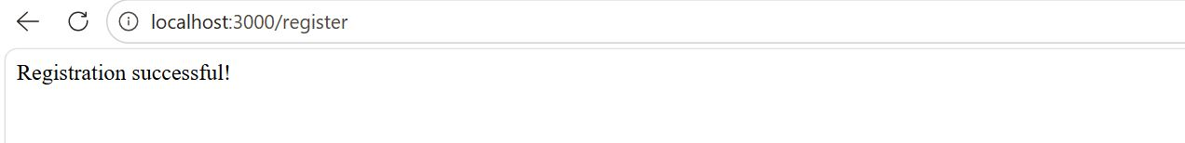
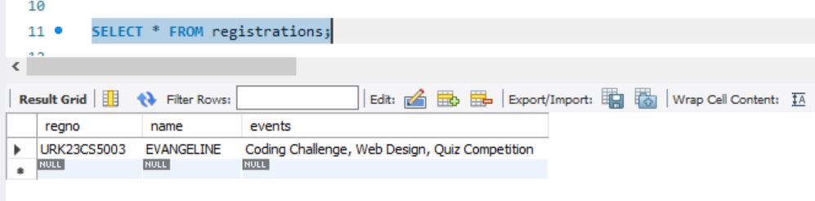
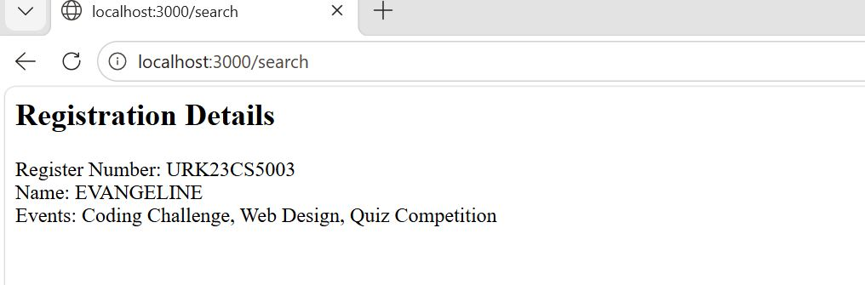

Result
The experiment was successfully completed.

